A River Runs Through It-Watershed Art Installation
Subject: Science / Hydrology
Grade Level: 8
Lesson Plan: Six 50-minute classes

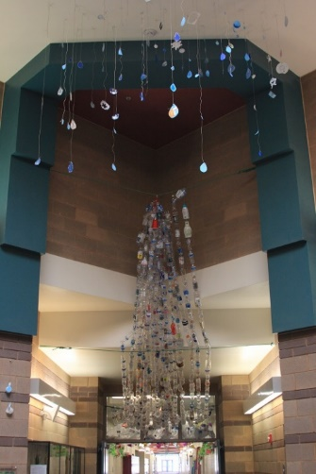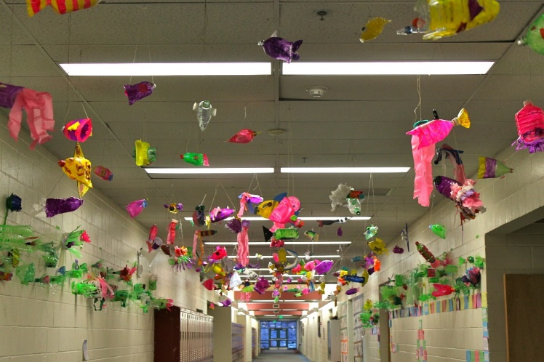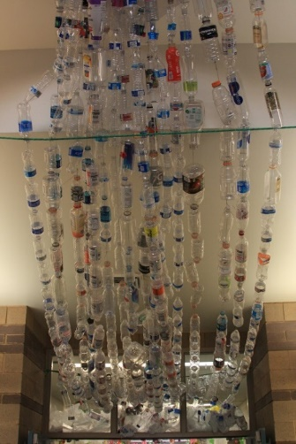

Students work together to create an art installation of a watershed. Recycled plastic serves multiple purposes in this project: it is reusable, economical material; it reflects the plastic waste that is in our water; and it shows students how much plastic we consume. Students create part of a waterfall, a fish, and a plant while learning about the different components of a watershed, including human impact on a watershed.

Objectives:
- Students will create elements of a watershed using recycled plastics
- Students will identify elements of human impact on a watershed
- Students will create an art installation representing a watershed

Basic Outline of the Lesson:
- Introduce the project – slide show
- Students create a waterfall, plants, and fish
- The watershed is assembled in the installation location

Art Supplies:
- Watercolor paints
- Acrylic paints
- Modge podge
- Paint brushes
- Water cups for brushes
- Scissors
- Plastic bottles
- Caps
- Tissue paper
- Glitter paint
- Colored masking tape
- Stapler
- Glue guns
- Hot glue
- Plastic film / plastic bags
- Hemp line / fishing line
- Thumb tacks
- Dowel or rod to hang the bottles
- Wire
- Wire cutters
- Eye screws
- Rope
- Colored pencils
- Drawing paper

Other Resources:
- Visual examples of fish and plants created from plastic
- Slide show to introduce project and related artwork (see outline at the end of the lesson plan)

Idaho State Learning Standards:
- Arts and Humanities: Anchor Standard 4: Convey meaning through the presentation/performance/production of an original work or unique interpretation of a work
  - Objective PR1.1 Combine knowledge and understanding from two or more disciplines to present/perform their original or interpreted works for an audience
  - Objective PR1.2 Convey meaning through their presentation/performance
- LS2-MS Ecosystems: Interactions, Energy, and Dynamics
  - LS2-MS-1. Analyze and interpret data to provide evidence for the effects of resource availability on organisms and populations of organisms in an ecosystem.
    - Further Explanation: Emphasis is on cause and effect relationships between resources and growth of individual organisms and the numbers of organisms in ecosystems during periods of abundant and scarce resources

  - LS2-MS-3. Develop a model to describe the cycling of matter and flow of energy among living and nonliving parts of an ecosystem.
    - Further Explanation: Emphasis is on describing the conservation of matter and flow of energy into and out of various ecosystems, and on defining the boundaries of the system
  - LS2-MS-6. Evaluate competing design solutions for maintaining biodiversity and ecosystem services
    - Further Explanation: Examples of ecosystem services could include water purification, nutrient recycling, and prevention of soil erosion. Examples of design solution constraints could include scientific, economic, and social considerations.

Academic Language:
- Subject area language: watershed
- Art language: art installation

Student Use of Vocabulary:
Students will use the words when creating their projects

Student Grouping:
Students will work individually or in small groups

Instruction:
Day 1 – Introduction
  - Introduce the project with a slide show (see additional resources)
    - Questions to ask:
    - What do you see here?
    - How do you think the artist created their work?
    - Why do you think the artist made this piece?
  - Students can use the paper and pencils to sketch ideas for fish and plants
Day 2 – Artmaking
  - Discuss the significance of using the water bottles: their symbolism, recycling, the damage of plastic waste
  - Demonstrate how to string the water bottles together (follow printed instructions included below)
  - Working in small groups, students should string together their water bottles to create a waterfall
Day 3 – Artmaking
  - Demonstrate plant creation with the class. Show the students examples of plastic plants.
  - Students start creating their plants. Encourage the students to employ the three art techniques: cutting, gluing and embellishment.
  - When students have finished their plants, decide how they will install them in the installation location
Day 4 – Artmaking
  - Go over the fish creation with the class, showing the students examples of plastic fish
  - Students begin creating their own fish
    - Encourage the students to employ the three art techniques: cutting, gluing and embellishment
  - When students have finished their fish, hang them up in the installation location
Day 5 – Artmaking
  - Students should use this period to finish any uncompleted work.
Day 6 – Presentation
  - Finish installation of student fish and plants in the installation location
  - When the watershed is complete, the class should go into the hallway to look at and discuss their work
    - Questions to ask:
    - What did we create?
    - What did you learn?
    - What is a watershed? What is your role in a watershed?
    - How did you like doing an art project to learn about science?

Additional Resources:
Instructional video at svmoa.org

Slide Show Outline:
Slide examples:
- We will think about:
    - What is a watershed?
    - Why are watersheds important?
    - What is our responsibility to a watershed?
- Our art is inspired by plastics and other pollutants and their effects on a watershed
    - Video: What really happens to the plastic you throw away? by Emma Bryce
- What is an art installation?
    - A 3D, sculptural piece of art that is designed for a specific space
    - The art is usually temporary and changes how people view the space
    - Examples: “Paper Planes” by Dawn Ng and “Melting Man” by Nele Azevedo
- Photo of recycled bottle waterfall by Chinese artist Wang Zhiyuan
    - Questions to ask:
    - What do you see here?
    - What is this made out of?
    - Where do you think this is?
    - What is the artist telling his audience?
    - How is this art related to water?
    - Why and how is this an art installation?
- Photo of plastic plants by Veronika Richterova
    - Questions to ask:
    - What do you see here?
    - What materials did the artist use?
    - How many bottles did she use?
- Photo of plastic leaves by Veronika Richterova
    - Questions to ask:
    - What do you see here?
    - What materials did the artist use?
    - How many bottles did she use?
    - How did she get the leaves to take their shape?
- Three ways of manipulating plastic
    - Cutting
    - Gluing
    - Embellishment
- Cutting
    - Takes away material
    - Creates details
    - Changes surface
- Examples of cut plastic
    - “Green Plant” by Artist Gulnuroz Daglar
    - Questions to ask:
    - What material is used here?
    - How does cutting change the material?
    - How much of the material has been taken away?
- Cut plastic art by Eduard Aldrovandi
    - Questions to ask:
    - What material is used here?
    - How many bottles do you see?
    - How do you think he did this?
- Gluing
    - We will be using modge podge and hot glue
    - What does gluing allow us to do?
    - Enables layering and embellishment
- Examples of Layering
    - Artists David Edgar and Jen Stark
    - Questions to ask:
    - What materials did the artists use?
    - How many layers can you see?
    - How does layering change the appearance of the materials?
- More examples of layering
    - Artists Aurora Robson and Michelle Reader
    - Questions to ask:
    - What do you see here?
    - How are they similar and how are they different?
- Embellishment
    - What is embellishment?
    - Decoration
    - Adding to
    - How can we embellish our plastic creations?
    - Paint
    - Add more plastic
    - Add other materials
- Examples of embellishment
    - “Wreath” by Leanne Stock
    - Questions to ask:
    - What do you see here?
    - How is this embellished?

Installation Directions:
Stringing together water bottles to create a waterfall:

    - Poke a hole in the plastic (nail or poking tool)
    - Run the string through the bottle
    - Make sure the beginning and end of the string are secure
    - Attach more water bottles
    - Attach your string of water bottles to a classmate’s string of water bottles

Creating a plastic fish:

- Choose a water bottle as the foundation for the fish
- Cut the water bottle in different ways to change the shape
- Take the cut pieces or other pieces of plastic and hot glue them onto the fish
- Embellish fish using paint, tissue paper, modge podge, glitter glue, and colorful tape
- Run a string through the fish so we can hang it in the hall

Creating a plastic plant:

- Choose a water bottle as the foundation for the plant
- Cut the water bottle in different ways to change the shape
- Take the cut pieces or other pieces of plastic and hot glue them onto the plant
- Embellish plant using paint, tissue paper, modge podge, glitter glue, and colorful tape
- Run a string through the plant so we can hang it in the hall

Funding for this lesson plan was made possible in part by the Institute of Museum and Library Services [MA-10-19-0563-19].
Additional funding provided by Wendy and Alan Pesky.

