Math Mandalas
Subject: Geometry
Grade Level: 7
Lesson Plan: Five 50-minute classes

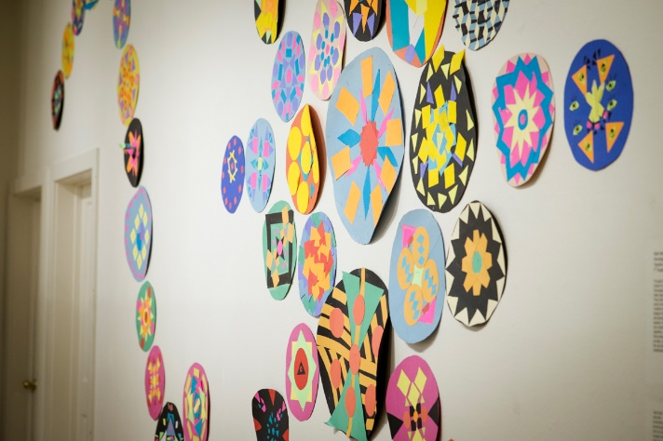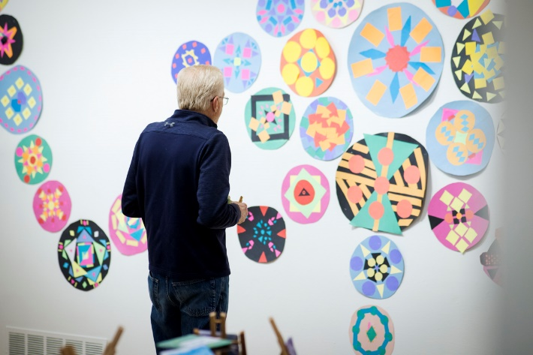

Students explore geometry concepts through their design and creation of mandalas. They will use their knowledge of circumference and area to develop a circle which will then become the container for their mandala designs and create their mandala by calculating the area and perimeter of different sized triangles and squares. Key concepts surrounding mandala design will be explored, including pattern, repetition, symmetry, proportion, and shape.

Objectives:
- Students will use formulas for area and circumference of a circle to develop a mandala
- Students will demonstrate understanding of the principles of symmetry, repetition, pattern, and shape through the design of their mandala
- Students will use at least three different sized shapes and calculate the area of each
- Students will choose at least one shape to create two different scales
- Students will write a two-to-three-sentence statement about their use of different formulas to construct their mandala

Basic Outline of the Lesson:
- Introduce the project
- Show a mandala in progress, explaining how the circle was calculated
- Students begin working on their mandalas
- Students continue working on mandalas
- Students continue and complete mandalas
- Students present and display their mandalas

Art Supplies:
- Poster board (multiple colors)
- Rulers
- Scissors
- Glue
- Pencils
- String

Other Resources:
- Examples of mandalas created
- Slide show to introduce project and related artwork (see outline at the end of the lesson plan)

Idaho State Learning Standards:
- Arts and Humanities: Anchor Standard 4: Convey meaning through the presentation/performance/production of an original work or unique interpretation of a work
  - Objective PR1.1 Combine knowledge and understanding from two or more disciplines to present/perform their original or interpreted works for an audience
  - Objective PR1.2 Convey meaning through their presentation/performance
- CCSS.MATH.CONTENT.7.G.A.1
Solve problems involving scale drawings of geometric figures, including computing actual lengths and areas from a scale drawing and reproducing a scale drawing at a different scale.
- CCSS.MATH.CONTENT.7.G.B.4
Know the formulas for the area and circumference of a circle and use them to solve problems; give an informal derivation of the relationship between the circumference and area of a circle.
- CCSS.MATH.CONTENT.7.G.B.6
Solve real-world and mathematical problems involving area, volume and surface area of two- and three-dimensional objects composed of triangles, quadrilaterals, polygons, cubes, and right prisms.

Academic Language:
- Subject area language: circumference, area, diameter, radius, and perimeter
- Art language: mandala, symmetry, repetition, pattern, shape, and mindfulness

Student Use of Vocabulary:
Students will use the words when creating their projects, when writing about their projects, and when discussing their projects

Student Grouping:
Students will work independently

Instruction:
Day 1 – Introduction
- Introduce the project with a slide show
  - Show art reflecting a relationship between math and art, and ask:
    - What do you see?
    - Why do you think the artists did that?
    - How do you think the artist did that?
    - How can you see math used in the art?
  - Discuss mandalas
    - What are they?
    - Where did they come from?
    - Why make them?
  - Introduce expectations and formulas
  - Discuss goals: art and educational
  - Show the beginnings of a mandala

Day 2 – Artmaking
- Demonstrate use of determining size, circumference, and surface area in creating a mandala
- Give students the remainder of the class to calculate their mandala size, circumference, and surface area

Day 3 – Artmaking
- Introduce incorporating shapes and designs into the mandala
  - Explain how to calculate the surface area of a triangle and a square
  - Demonstrate repetition, balance, and pattern
- Students will begin designing their mandalas using three different shapes

Day 4 – Artmaking
- Students will continue to work on their designs.
- Students will title their work and write an artist statement

Day 5 – Presentations
- Students will assist in the display of their artwork
- Students write their artist statement about their artwork if they have not already

Additional Resources:
Instructional video at svmoa.org

Slide Show Outline:
- Slide 1: Introduce the idea that math and art are related
  - How is math used in art? Where can we see its use in these pieces?
- What do you notice? How do you think the artist created their piece?
- What kind of math concepts did the artist use? What shapes do you notice?

- Slide 2–3: Proportion
  - What is proportion? When is something not in proportion?

- Slide 4–5: Symmetry
  - Introduce concept of symmetry?
  - How is this piece symmetrical? When would it not be symmetrical?

- Slide 6–7: Shapes and Form
  - Identify shapes in the image. What are some that you found?
  - Shapes can be present in nature and manmade
  - How do you think the artist created the shapes?

- Slide 8: Measurement and Perspective
  - Discuss how measurement is used in the art pieces
  - How does measurement contribute to perspective? How are they related?
  - How will you use measurement?

- Slide 9: Introduce Mandalas
  - Is anyone familiar with them? Where have you seen them? Have you ever created one?
  - Consider process through cause and effect, compare/contrast, and argumentation

- Slide 10: Intention and Mindfulness
  - Briefly review both these ideas and how they will be used

- Slide 11: How Mandalas Are created

- Slides 12–14: Creating Your Mandala
  - Slide 12: Setting an intention
  - Slide 13: Your Circle-equations for circumference and area
  - Slide 14: Adding to your Mandala- equations for perimeter and area
- Introduce pattern and go over pattern/repetition
- Slide 15: Art Goals

- Slide 16: Education Goals

- Slide 17: Resources

End of project artist reflection and presentation:
- State your intention and briefly describe Mindful process
- Explain development of your mandala, how did you decide on colors/shapes/arrangement?
- How did you use math to create your mandala? Did it help you familiarize with the concepts?

Funding for this lesson plan was made possible in part by the Institute of Museum and Library Services [MA-10-19-0563-19].
Additional funding provided by Wendy and Alan Pesky.

