Data Sculptures: Visually Representing Data

SUBJECT: Science
GRADE LEVEL: 7
LESSON PLAN: Six 50-minute classes

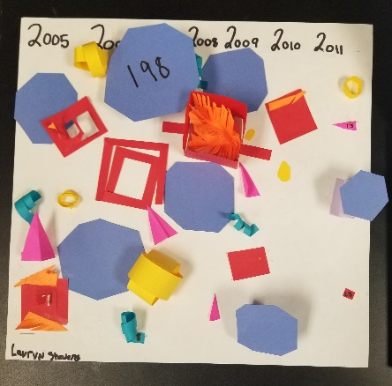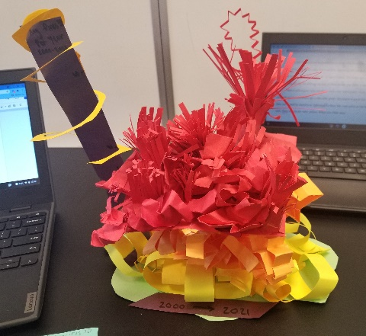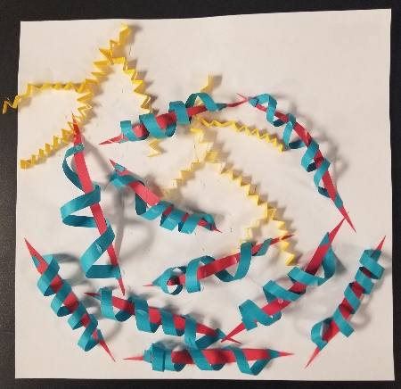

Students will explore 7th grade science concepts by studying weather data and learning how to translate that data into a three-dimensional sculpture. Different data sets include snow fall, river levels, fire data, etc. Students will assign a color and a shape or form to each different piece of data. They will then sculpt each type of data using paper sculpture techniques. When finished, students will have a sculpture that communicates their chosen weather data visually.

OBJECTIVES:
- Students will explore a variety of weather-related data sets.
- Students will identify color, shape and form as elements of art.
- Students will translate their chosen weather data into visual representations of color, shape and form.
- Students will demonstrate a variety of paper sculpting techniques.
- Students will write a three-to-four sentence statement about their artwork

BASIC OUTLINE OF THE LESSON:
- Introduce the Project and share slideshow.
- Students will review and select their data set.
- Students finalize their data translation plan on brainstorming worksheet.
- Students are introduced to a variety of paper sculpting techniques and begin sculpting.
- Students will be introduced to a variety of attachment techniques and continue sculpting.
- Students display their work and artist statement, give feedback and discuss.

ART SUPPLIES:
- Pencils and erasers
- colored pencils
- paper in various colors
- grocery bags to hold sculpted pieces in between days
- scissors
- glue sticks
- heavy paper to mount sculpture (cardstock)

OTHER RESOURCES:
- PowerPoint slideshow
- Brainstorming worksheet

IDAHO STATE LEARNING STANDARDS:

- Arts and Humanities: Anchor Standard 2: Organize and develop artistic ideas and work.
  - VA:Cr2.1.7a: Demonstrate persistence in developing skills with various materials, methods, and approaches in creating works of art or design.
  - VA:Cr2.3.7a: Apply visual organizational strategies to design and produce a work of art, design, or media that clearly communicates information or ideas.
- Arts and Humanities: Anchor Standard 3: Refine and complete artistic work.
  - VA:Cr3.1.7a: Reflect on and explain important information about personal artwork in an artist statement or another format.
Science Objective: Analyze and interpret data on natural hazards to forecast future catastrophic events and inform the development of technologies to mitigate their effects.

ACADEMIC LANGUAGE:
- Subject area language: data, data set, weather, observation, translation, variables
- Art Language: Sculpture, form, shape, color, 2D, 3D

STUDENT USE OF VOCABULARY:
Students will use the words when creating their sculptures, when writing about their work, and when discussing their projects.

STUDENT GROUPING:
Students could work in pairs or independently.

INSTRUCTION:

DAY 1 — INTRODUCTION
Introduce the project through the slide show.
- Show students the work of artists who use data as the inspiration for their artwork
- Engage students by encouraging them to critically think and ask:
  - How could you translate numbers into art?
  - What might that look like?
- Introduce the project goal of creating a sculpture that visually communicates their weather data. Finally, begin brainstorming and go over expectations.

DAY 2 — ARTMAKING
- Students will finalize their data translation plan.
- They will be introduced to various paper sculpting techniques and begin to sculpt pieces of data.

DAY 3 — ARTMAKING
- Students given tips for attaching sculpted papers to paper base.
- Students continue sculpting.

DAY 4 — ARTMAKING
- Students continue working on their sculptures.

DAY 5 — ARTMAKING
- Students continue working on and finish their sculptures.

DAY 6 — PRESENTATIONS
- Students will title their work and write artist statement paragraph.
- Students will display their artwork and artist statement and participate in a gallery walk where they will observe each other’s works and give feedback to at least two of their peer’s work. Class discusses what they observed in their peer’s work.

SLIDE SHOW OUTLINE:
- Share the work of data artists
- Show a brief history of paper art around the world & other paper artists
- Introduce planning/sorting data
- Share data sets
- Brainstorming
- Composition tips
- Paper sculpture techniques
- Composition review
- Attachment techniques
- Project check-In
- Artist statement question prompts to help students write their own artist statement
- Resources

END OF PROJECT ARTIST REFLECTION AND PRESENTATION:
- What is your sculpture called?
- What colors did you use in your sculpture? Why, what do they represent?
- What do the different shapes and forms represent in your sculpture?
- How does the arrangement of your sculpture (the composition) help to communicate your data?

