Inventing for the Future-Science Sculptures

SUBJECT: Science
GRADE LEVEL: 8
LESSON PLAN: Six 50-minute classes

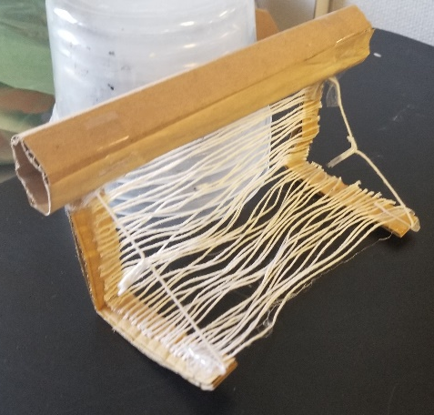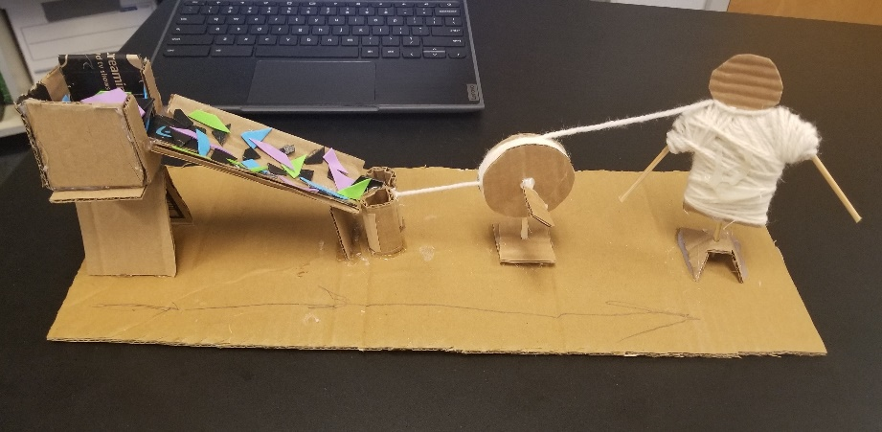

In this project, students explore 8th grade science concepts involving adaptations. We will discuss as a class how the environment is changing and what adaptations or inventions may be needed in the future. Students will consider issues like forest fires, rising temperatures, clean water, pollution, the food supply chain, etc. They will then sculpt a model of their invention or adaptation. Students will use materials like cardboard, paperboard, plastic containers and lids to construct their models. Students will learn to translate their 2D sketch into a 3D model.

OBJECTIVES:
- Students will brainstorm at least three different ideas of possible adaptations or inventions that could help humans in the future.
- Students will determine which idea they will pursue.
- Students will fully draw their idea from two different angles to get a better understanding of the objects full form (translation from 2D to 3D).
- Students will sculpt a 3D model of their adaptation.
- Students will write a three-to-four sentence statement about their artwork.

BASIC OUTLINE OF THE LESSON:
- Introduce the project and share slideshow.
- Students will determine their adaptation/invention and draw it from two different angles to better understand its form (translate from 2D to 3D).
- Students will begin sculpting their idea.
- Students finalize their sculptures.
- Students display their work and artist statement, give feedback and discuss.

ART SUPPLIES:
- extra blank paper for drawing idea from two angles
- pencils and erasers
- scissors
- Xacto knives
- cardboard pieces and paperboard pieces
- masking tape/duct tape
- cardboard tape and sponges
- hot glue sticks and gun
- (encourage students to bring items from home to add to the supplies)

OTHER RESOURCES:
- PowerPoint slideshow
- Brainstorming worksheet
- Final drawing worksheet

IDAHO STATE LEARNING STANDARDS:
- Arts and Humanities: Anchor Standard 1: Generate and conceptualize artistic ideas and work.
- VA:Cr1.1.8a: Document early stages of the creative process visually and/or verbally in traditional or new media.
- Arts and Humanities: Anchor Standard 2: Organize and develop artistic ideas and work.
- VA:Cr2.1.8a: Demonstrate willingness to experiment, innovate, and take risks to pursue ideas, forms, and meanings that emerge in the process of artmaking or designing.
Science Objective(s):
- MS-LS2-4. Construct an argument supported by empirical evidence that changes to physical or biological components of an ecosystem affect populations.
- MS-LS2-1. Analyze and interpret data to provide evidence for the effects of resource availability on organisms and populations of organisms in an ecosystem.
- MS-LS2-5. Evaluate competing design solutions for maintaining biodiversity and ecosystem services.
ACADEMIC LANGUAGE:
- Subject area language: adaptation, invention, environment, observation
- Art Language: sculpture, form, 2D, 3D, model

STUDENT USE OF VOCABULARY:
Students will use the words when creating their sculptures, when writing about their work, and when discussing their projects.

STUDENT GROUPING:
Students will work independently.

INSTRUCTION:

DAY 1 — INTRODUCTION
Introduce the project through the slide show
- Show students the work of Leonardo da Vinci and a short video.
- Also the work of Alexander Calder and a short video.
- Engage students by encouraging them to critically think and ask:
  - How might our environment change in the future?
  - What needs might humans have in the future?
- Introduce the project goal of sculpting a model of an adaptation or invention for a possible future need.
- Discuss project expectations
- Begin brainstorming at least three different ideas

DAY 2 — ARTMAKING
- Students will determine their favorite idea and draw it from two different angles to get a better understanding of the object’s full form (translate idea from a 2D drawing, to a 3D model).

DAY 3 — ARTMAKING
- Students are given tips for sculpting with cardboard and begin the sculpting process.

DAY 4 — ARTMAKING
- Students continue working on their sculptures.

DAY 5 — ARTMAKING
- Students continue working on their sculptures.

DAY 6 — PRESENTATIONS
- Students will write artist statement paragraph.
- Students will display their artwork and artist statement and participate in a gallery walk where they will observe each other’s works and give feedback to at least two of their peer’s work. Class discusses what they observed in their peer’s work.

SLIDE SHOW OUTLINE:
- Show the work of Leonardo da Vinci and Alexander Calder
- Discuss the design process compare/contrast to the artistic process
- Share project goals
- What is sculpture?
- Brainstorming
- Our Design Process
- Translating from 2D to 3D with drawings
- Planning and materials
- Sculpting tips
- Artist statement question prompts to help students write their own artist statement
- Resources

END OF PROJECT ARTIST REFLECTION AND PRESENTATION:
- What is your sculpture called?
- Your sculpture is a model of an invention, what does your invention do?
- What materials did you use to construct your model?
- How does it help people?
- Why is this important to you/Why did you choose this invention?

